Low Lives Saved Estimates

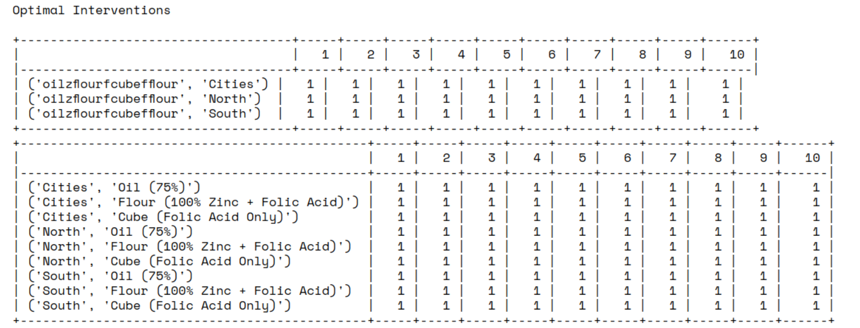

The table above shows the optimal interventions for the low lives saved estimates. The top table shows the optimization output with what the name of the intervention is. The bottom table shows the choices for each intervention in across space and time.

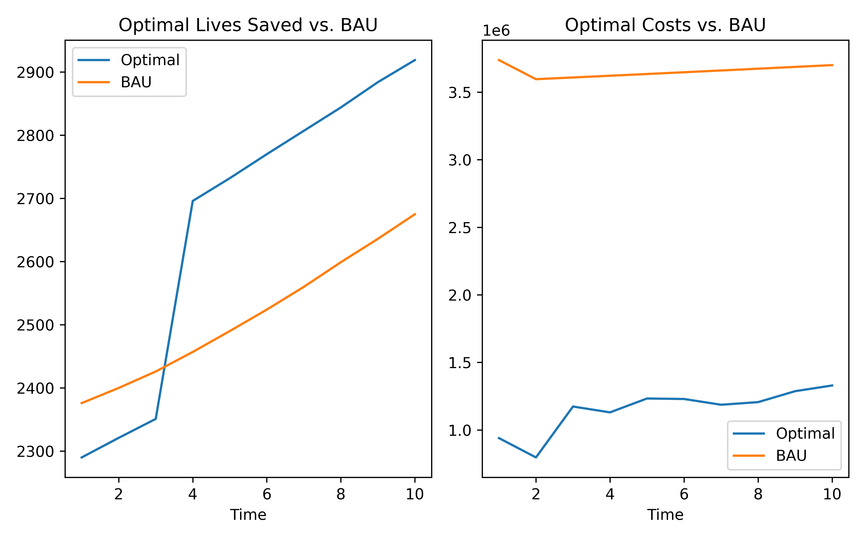

High Lives Saved Estimates

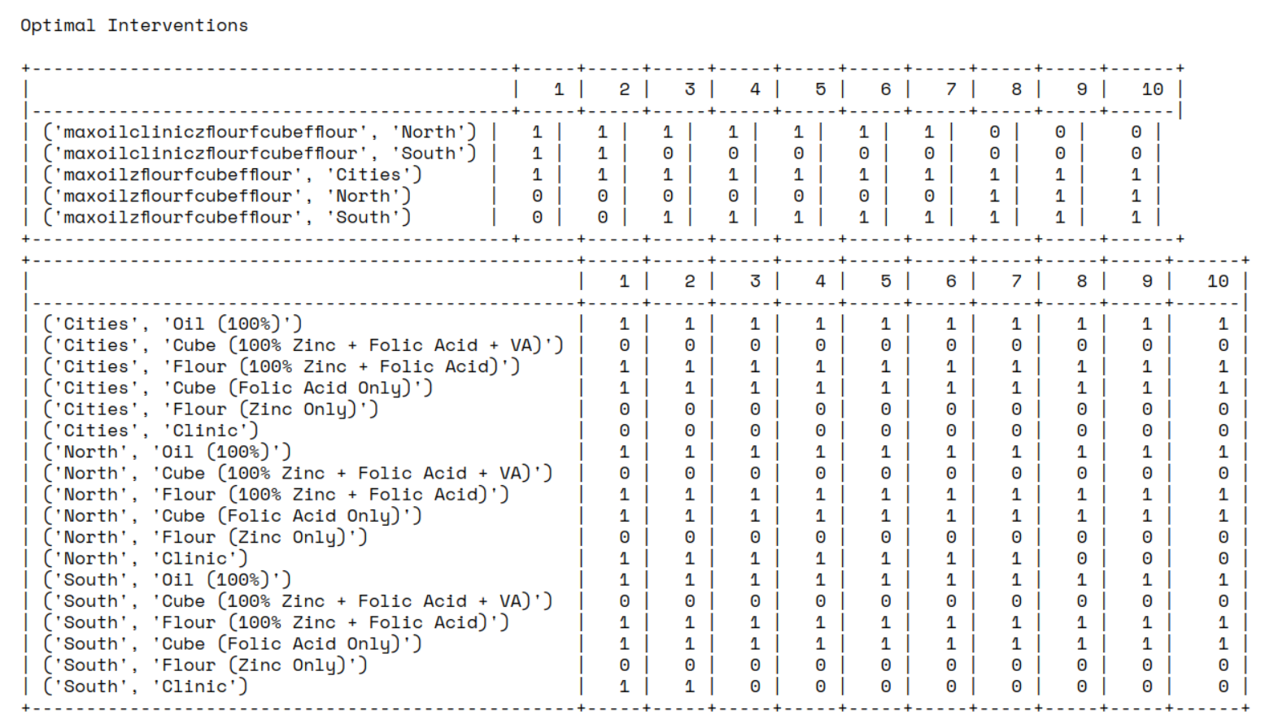This has the same interpretation as the table above, only it applies to the high estimates of lives saved.

